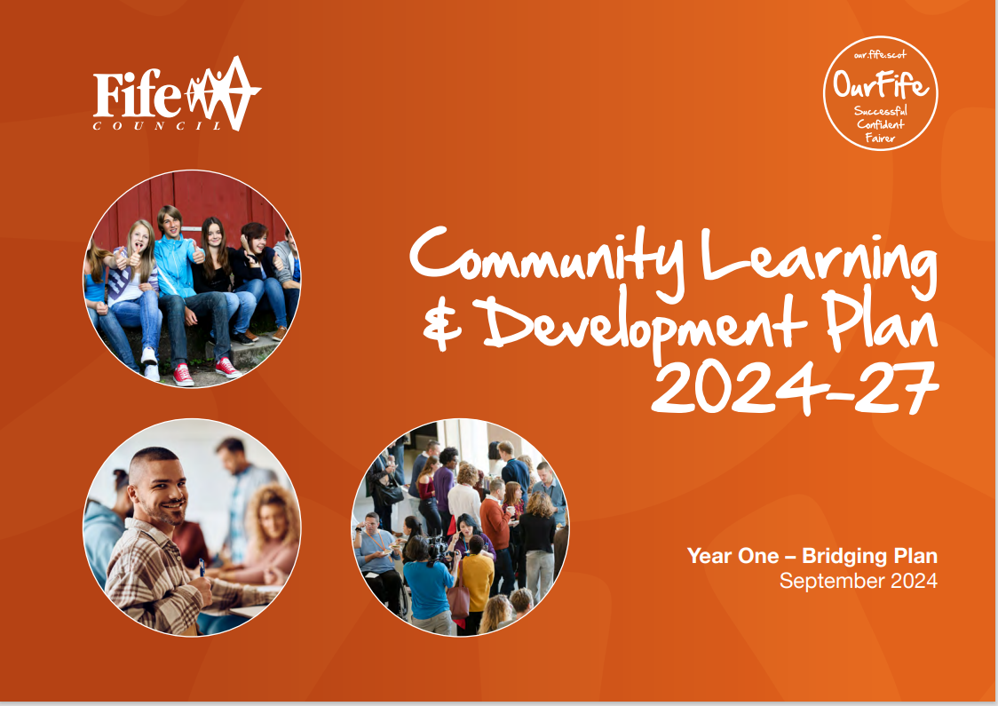

North East Fife Area Delivery Plan
Year One
September 2024 to August 2025

Opportunities for All
Opportunities for All is about ensuring that no-one is left behind. We aim to ensure that every Fifer can access opportunities in education, training, jobs and wider society, and that all Fifers have equal access to the support and advice they might need to support a fulfilling and decent life.
Expected Change | CLD Outcome | Actions for Year 1 | Partners  Lead / Contributing | Measures of Success | Progress
Adult Learning
All community based adult learners have improved skills across the four thematic areas of family, work, community and personal skills. | AD1 AD3 | Establish LPG vision, aims & objectives for local adult planning group (ALPG)  Carry out an adult learning survey to identify the needs and aspirations of future CBAL learners.  Target the promotion of CBAL opportunities in areas of most need in NEF  Continue to provide digital skill support to individuals through 1-1 and outreach classes | Lead Partner: Local Adult Learning Planning Group (ALPG)  Other Partners:  All involved in ALPG  CLD  CLD | Agreed structure in place and delivery group meeting regularly  KP11, KPI 2, KPI9  Delivery in new areas of NEF  Attendances at digital skills on Cognisoft and ILP
 | AD1  AD2  AD3  AD4  AD5 | Develop and provide family learning experiences in areas of NEF | ALPG, CLD, Education, Cupar YMCA/YWCA, CUS, local businesses, activity providers, land owners | KP14, KP15, KPI13
Improved adult literacy and numeracy for adults in NEF | AD1  AD3  AD5  AD7 | Continue to provide learner-centered classes with a focus on literacy, numeracy and ICT. Encourage learners to complete an SQA qualification at an appropriate level.  Promote ABE learning opportunities throughout NEF. | Lead Partner :ABE  Contributing  Partners: CLD, Cupar YMCA/YWCA, Cupar Youth Cafe | KPI1, KPI2, KPI3,
Improve wellbeing of individuals and communities |  | Provide CLD social prescribing role in Cupar area and increase engagement in CLD activity  Investigate and develop appropriate measures for increased wellbeing when engaged in CLD activity | CLD, Cupar Health Centre  Lead Partner: CLD  Contributing Partners: Cupar YMCA/YWCA, Cupar Youth Cafe  Cupar Mental wellbeing network, Health and social care | KPi9, KPi10
CCB
Improved local outcomes delivered through local community plans, neighbourhood plans, and community led action plans. | CD1  CD2  CD5  CD6 | Strengthen our engagement with key organisations in NEF to identify local issues and develop rural initiatives. | Lead Partner: CLD  Contributing partners: RPAG, Health and Social care, NEF Community Centre network, Larick Centre, Dolphin CC, Forgan Arts, CIC, Education | KP11, KP13
 |  | CEW support to our local vol centres to develop and deliver locally based community provision | Lead Partner: CLD  Contributing partners: Cupar YMCA/YWCA, Cupar Youth Café, NEF Community HUB, | SLA annual monitoring and 3-year evaluation
 |  | Support to Community Groups on Governance arrangements | Lead Partner: FVA  Contributing Partner: CLD
Sustainable community approaches and access to basic food security and health information |  | Continue to support NEF Food Development Worker to support local community food provision and support local volunteers with access to relevant training and qualifications | Lead Partner: CLD  Contributing Partners: NEF Food Providers | Numbers of groups operating in NEF, number of registered volunteers in local food provision  KPi 3, KPi9, KPi11
Improve Digital Access across NEF area |  | Develop and promote community and individual digital services and  Increase local promotion across services and organisations.  Increase access to local learning centres | Lead Partner: CLD  Contributing partners: RPAG, Community Centre Network, Digital Fife | Provision of resources, Community digital classes  NEF groups on Digital Fife, social media  Increased sharing/promotion on Our NEF
Youth Work
Young people’s achievements are fully recognised | YW3  YW6  YW7 | Increase numbers of YP receiving nationally recognised awards.  Hold an annual celebration of achievement | Lead Partner: CLD  Contributing Partners: Cupar YMCA/YWCA  Cupar Youth Cafe  NEF Youth Partnership | KPI6, KPI7, KPI8  KPi13
Young people make a successful transition from school and beyond. | YW1  YW2  YW3  YW4  YW7 | Attend and Support school partnerships in NEF  Deliver targeted schoolwork programmes in x3 high schools in NEF  Provide P7 transition events/projects  Develop and support youth employability programmes  Delivery of alternative outdoor project targeting pupils not engaging in school or at risk of anti-social | Lead Partner: CLD  Contributing Partners: Cupar YMCA/YWCA  Cupar Youth Cafe  NEF Youth Partnership  Lead Partner: NEF Youth Partnership  Other Contributing Partners  Cupar Youth Cafe  CLD  ABE  Education  EASY P partnership  Fife College  Lead Partner: CLD  Contributing Partners: Safer Communities, St Andrews Botanic gardens | KPI6, KPI7, KPI8, KPI10  KPI6, KPI7, KPI8  KPI6, KPI8, KPI13  KPI6, KPI7  KPI6, KPI7, KPI8, KPI9,
Young People are involved in shaping and informing the delivery of local youth work services. | YW2  YW6  YW7  YW1  YW2  YW3  YW4  YW5  YW6  YW7 | NEF Youth Partnership agree visions, aims and Objectives and key areas of work for 25/26  Development of a NEF Youth voice group  Continued support to local MSYPs  Carry out a youth survey with young people in NEF to identify needs and aspirations for youth work delivery  Engaging young people from East Neuk in the development of the local Fife Development Plan  Delivery summer provision for young people as a youth partnership  Delivery of universal and targeted youth projects work across NEF  Increase the number of registered young volunteers in a CLD setting | Lead Partner: CLD  Contributing Partners: NEF Youth Partnership  Lead Partner: CLD  Contributing Partners: NEF Youth Partnership  Lead Partner: CLD  Contributing Partner: Cupar Youth Cafe, Cupar YMCA/YWCA, NEF Youth Partnership  Lead Partner: CLD  Contributing Partners, Education, local action group, East Neuk Youth partnership  Lead Partner: NEF Youth Partnership  Contributing Partner: NEF Youth Partnership  Lead Partner: CLD  Contributing Partners: Cupar Youth Cafe, Cupar YMCA/YWCA, NEF Youth Partnership, Larick Centre, Leuchars MOD, Safer Communities  Police, Fire Service, Botanic Gardens, East Neuk Outdoors,  Lead Partner: CLD  Contributing Partners: Cupar Youth Cafe, Cupar YMCA/YWCA, NEF Youth Partnership, Larick Centre, Leuchars MOD, NEF community Centre network | KPI12  MSYPS engaged locally, fife wide and nationally  Collation and report on responses from survey  KPI6  KPI10, KPi13  KPi6, KPi13  KPi6, number of communities delivered  KPi6, KPi7, KPI8  Numbers of registered with FC, numbers registered with Cupar YMCA/YWCA
Anti-poverty
Increase income of people in NEF through ensuring access to support is available to those in crisis  Improve local intelligence and collaboration to proactively reach people in need impacted by cost of living and residing in rural communities  Local people are influencing service delivery and approaches  Improve Access to Services in NEF | CD2  CD1 and CD2  CD6 | Delivery of welfare support in 5 ward areas of NEF and targeted outreach support to protected communities and isolated  Rural poverty action group (RPAG) continue to meet 3 times per year and work towards the 8 priority themes in the action plan  Expand across NEF organisations who can provide anti-poverty minimum offer of information and knowledge on local welfares supports  Evaluation of local cash first approaches to shape future delivery  Formation of a local rural voices panel to shape and contribute to future anti-poverty delivery  Delivery of warm spaces in local community organisations  Increase access to local community banking solutions in East Neuk  Promote money management and saving through  Travel voucher scheme continues with increased partners/services engaged | Lead Partner: CLD  Contributing partners RPAG  Lead Partner: CLD  Partner Organisations: RPAG, Community centre network  Lead Partner: RPAG  Contributing partners: CLD  Lead Partner: CLD  Contributing Partners: RPAG  Lead Partner: CLD  Contributing Partners: RPAG  Lead Partner: CLD  Contributing partners RPAG, community centre network  Lead Partner: RPAG, Kingdom Community Bank  Contributing Partners: CLD  Lead Partner CLD, RPAG | Numbers attending job clubs, numbers receiving 1-1 support, number of those referred to other partners  Evaluation of the 23-26 action plan  Annual report  KPI11  Numbers of groups/orgs accessing Benefit checker and energy training  Map of local organisations providing minimum offer  KPI11  Evaluation report produced with learning and recommendations on NEF cash first approaches  Group established with aims and objectives agreed  KPI12  Evaluation of funding received and case studies  Numbers signed up for the service  Delivery of local courses money matters, making ends meets  Evaluation and report on 24/25 travel voucher scheme and

Thriving Places
Thriving Places are safe, well designed and maintained places that promote wellbeing, where people are proud to be, and where they have access to the services and facilities, they need at different stages of their lives.

Expected change | CLD Outcome | Actions for Year 1 | Partners  Lead / Contributing | Measures of Success | Progress
ESOL learners, including New Scots participating in ESOL and local community activities as part of their integration into Fife. | AD3  AD4  AD5  AD6  AD7  CD1  CD2  CD3  CD4  CD7  AD1  AD2  AD5 | Provide ESOL classes in accessible locations.  Deliver community programmes to support ESOL learners to participate in wider community-based learning opportunities.  Deliver briefing sessions for staff teams to raise awareness of New Scots families settling in their area and how best to engage and promote family and community learning opportunities.  Increase the number of volunteering opportunities available to support ESOL families, or for ESOL learners to participate in. | Reporting Partner:  Communities and Neighbourhoods (ESOL)  Contributing Partners:  Housing Service  Education Service  Link Living  ABE  University of St Andrews  Fife International  Forum  Fife Voluntary Action  NHS Fife  Police Scotland Fife | KPI1  KPI2  KPI13
Communities are actively contributing to reducing climate crisis concerns |  | Grow our ability to engage more in this area and work with partners and local communities to find solutions to address this, as well as other social issues.  Support to local community action food growing groups.  Development of community garden outdoor spaces  Delivery of STEM activities with young people, adults and families in local community venues  Support to local voluntary centres to improve energy efficiency and climate approaches | Lead Partner: CLD, RPAG  Transitions  StAn Environ Network  Cupar YMCA/YWCA  Lead Partner: CLD  NEF Youth Partnership, local businesses  Contributing Partners: Community Centre Network, StAnd Environment network | Food network group meets regularly  New groups  Delivery of local projects

Community Led Services
Community Led Services means putting communities and service users at the heart of how we design services and building on the strengths and assets we have in our workforce and in our communities in order to deliver valued services.

Expected change | CLD Outcome | Actions for Year One | Partners  Lead / Contributing | Measures of Success | Progress
Individuals and community groups have the capacity to get involved and develop confidence to make changes to enable their communities to grow and develop.  Improve communities and individuals' wellbeing | CD1  CD2  CD3  CD4  CD5  CD6  CD7 | CEWS continue to provide link officer support to key voluntary organisations in NEF with SLAs over £10,000  Continue to support and develop the community food providers across NEF  Cupar mental health and well-being network share information about services and opportunities in the Cupar area relating to mental health and wellbeing | Lead Partner: CLD  Contributing Partners:  FVA  Lead Partner: CLD  Contributing Partners:  Local voluntary organisations  Lead Partner: Cupar YMCA/YWCA  Contributing Partners:  CLD, Health and social care partnership, local voluntary groups | SLA annual reviews, 3-year evaluation  Numbers of community food providers in NEF and attendances  KPI11  Notes of meetings and group actions plan, locally produced brochure of services | End of year 1 evaluation in progress
 |  | Continue to support NEF Community Centre Network meetings | East Neuk Trust, Cosmos Community Centre, TICC, Auchtermuchty CC, Rio Community Centre, Larick Centre | Notes of Meetings
Community Groups in NEF are sustainable and able to deliver effectively in their local areas | CD1-7 | Support community groups to achieving successful funding applications by hosting an annual funding event in NEF | Lead Partner: FVA  Contributing partner: CLD, Community Centre Network, Fife funding team, National lottery | Successful applications  Attendance at event  Increased applications to local funding
 |  | Support to Community Groups on Governance arrangements | Support to Community Groups on Governance arrangements | Groups receiving support

Inclusive Growth and Jobs
Growth in the local economy should benefit everyone and shouldn’t pass people and places by. We will therefore focus on improving investment, growth and participation by businesses, people and communities, particularly in the NEF area. We aim to support businesses to grow and to make sure that communities benefit from new business investment.

Expected change | CLD Outcome | Actions for Year One | Partners  Lead / Contributing | Measures of Success | Progress
Improving and building on individuals employability  Skills  Increase Community Wealth initiatives in NEF | CD3  CD3  CD2 | Provide volunteering training opportunities and celebration of achievement event  Continue to provide student placements for those undertaking CLD related qualifications  Improve employability pathway support in local area, identifying key gaps in employment areas in NEF  Continue to support project assistant posts to develop the lived experience contribution to service delivery  Roll out of cash first approach using Fife Loves Local vouchers  Recruit new businesses in NEF to take part in Fife Loves Local | Lead Partner: CLD  Contributing partners: Community Centre Network, FVA  Lead Partner: CLD  Contributing partners: Dundee University, Fife College  Lead Partner: CLD, FC Employability Team  Lead Partner: CLD  Lead Partner: CLD  Contributing Partner RPAG, Local businesses | Number of volunteers participating in NEF CLD activity and in the wider community organisations  Training courses and attendances  Current numbers on CLD work based route in the team and HNC working with communities  RPAG report  RPAG annual report  Evaluation of use of vouchers  Increased business participation | Planning for volunteer training April/May 25

